Operating System (OS): is a software system that controls and manages hardware components and controls software resources to provide a service /program.

A computer is based on :
Operating System (OS)
Hardware | OS base
CPU(processors) | File manager
Memory | Programs
Storage | Threads
Network | Communication
Monitor | GUI
USB | input/output(physical)

the hardware components are the physical part in a computer, software is the non touchable part in a computer.
OS is the main software thing that connects the hardware with the software and takes precautions to make sure that you are using the hardware in safe way the wont ruin the hard ware but the same time be as efficient as possible.
For that to happen there are technique to do that:

Technique | Description
virtual memory | It is a memory management technique that enable the computer to make for the low sophistical ram storage by using the hard disk and it called swap storage  benefits :  - the OS can run programs that are bigger than the ram limitation  - it better in security because it requires mapping to keep the connection between the data in ram and sata storage.
multitasking | It is to run more than one program at the same time in the same computer which also uses all the computer devices at the same time and it better because it increases efficiency.
scheduling | Is the method that is used to assign and use the the resources of the computer hardware and it also controls the time memory and bandwidth of each processes/threads  - use the components of the computer for as much as possible  - it ensures the fairness in using the hardware components
policies | Given a specific task, the strategy refers to what needs to be done (that is, the activity to be performed), and the mechanism refers to how to do it (that is, the implementation to execute the strategy). In other words, the separation of mechanism and strategy is a design principle of computer science. It points out that the mechanism (those parts of the system that controls operation authorization and resource allocation) should not specify (or excessively restrict) policies, based on which decisions to authorize which operations and which resources are allocated. Please distinguish between policies and mechanisms. Strategy is the method of choosing which activities to perform. The mechanism is the realization of the execution strategy.
interrupt | In machine programming, an interrupt is a sign to the processor emitted via way of means of hardware or software program indicating an occasion that desires on the spot attention. An interrupt signals the processor to a high-precedence circumstance requiring the interruption of the modern code the processor is executing. The processor responds via way of means of postponing its modern activities, saving its state, and executing a characteristic referred to as an interrupt handler (or an interrupt carrier routine, ISR) to cope with the occasion. This interruption is temporary, and, after the interrupt handler finishes, the processor resumes regular activities. There are styles of interrupts: hardware interrupts and software program interrupts.
paging | Polling, or polled polling operation, in computer science, refers to the client program actively sampling the status state of an the external device by a client program as a synchronous synchronization activity.  - The polling period is the time each element is monitored once. The optimal polling period will vary based on several factors, including the required response speed and polling overhead (for example, processor time and bandwidth).  - In roll call, the polling device or process queries each element in the list in a fixed order. Because it waits for the response of each element, it needs a timing mechanism to prevent locks caused by non-responsive elements. If the overhead of polling messages is high, there are many elements to be polled in each polling cycle, and only a few elements are active, then roll-call polling may be inefficient.  - In hub polling, additionally called token polling, every detail polls the subsequent detail in a few constant sequence. This maintains till the primary detail is reached, at which period the polling cycle begins offevolved throughout again

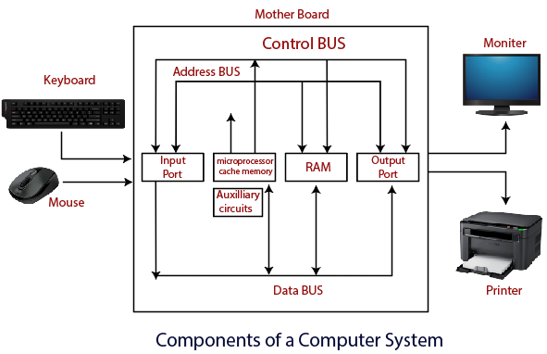

we are about to talk about the problems that this system can solve and optimizing, and testing a
specific system component.
- Lagging and being unable to delver due to problem in scheduling which means you need do some threading test and we do this in c language through using fork Lib and some location pointers that would return data that we can work with.
- Testing input and output in the program is necessary to what kind of data do you save and what happens to the file types to be read within the same system/program that need to be tested.
- We do memory testing through using libraries in c language that would make it possible for us to see where and what in the memory is happening

Last update

